1.first of all, make sure you have the

<https://github.com/iwi-games/as3-slots-harness.git>

cloned to your PC

2.checkout to the mobile branch

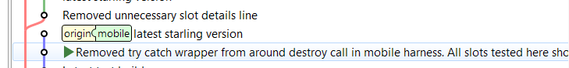

3. import the project to flashbuilder

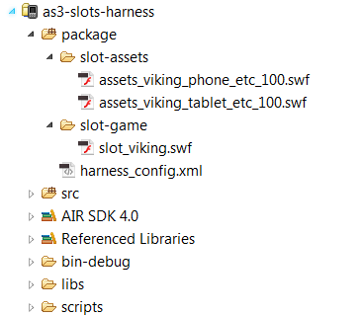

4. copy the etc.swf which is released from your flash project to package/slot-assets

and the slot_***.swf which is also released from your flash project to package/slot-game.

5.config the harness_config.xml

eg:(if you want to package tablet version)

<slot filename=*"slot_viking.swf"*

isStarling=*"true"*

scaleFactor=*"1"*

layout=*"tablet"*

language=*"language_EN"*

os=*"Android"*>

<assetPack os=*"Android"* fileName=*"assets_viking_tablet_etc_100.swf"*/>

<assetPack os=*"iOS"* fileName=*"x1.0/assets_chuzzleslot_tablet_png.5"*/>

</slot>

<debug mode=*"1"* />

<user id=*"123456"* />

6.clean and package the game.make sure you have connect the device first.

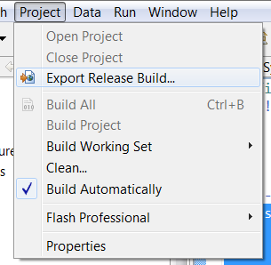

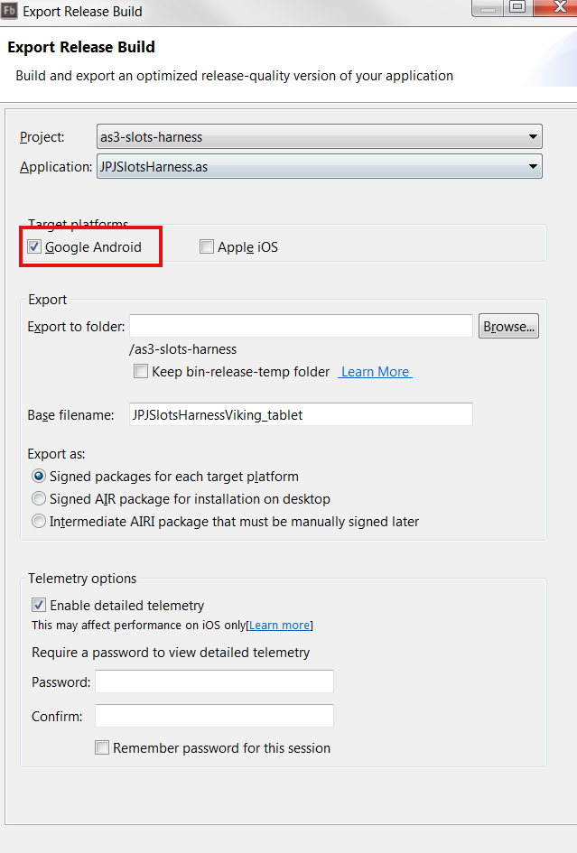

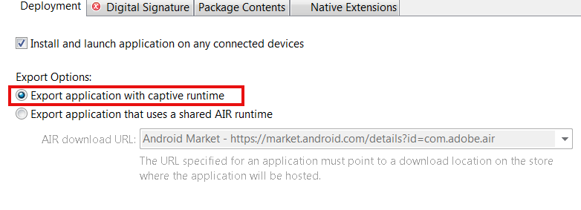

If you dont have the cert, just create it.

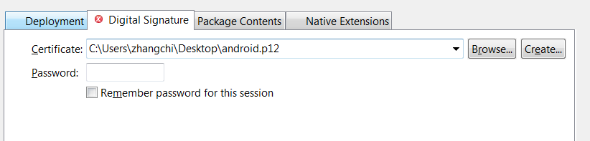

make sure you have choosen all the contents

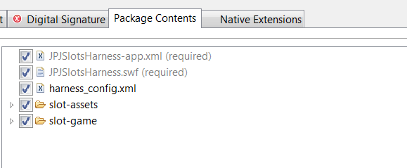

click finish to export it to your device, and enjoy.